Group Project 2: Tableau

Allison Keonhothy, Arya Telang, Harrison Barnes, Zeniyah Bhojani

Professor Askhat Lakhiwal

Tues/Thurs 2:20 pm

Database 2

Describe your dataset and what data it contains: 2

The 2 questions the team generated and why they are interesting and important: 2

Question 1:What are the 5 most common crimes reported in the Los Angeles area from 2023-2024? 2

Question 2: Among these crimes, what areas are they being committed in the most?

The manipulations applied to the data set as part of the analysis: 2

# **Database:**

[Crime Data from 2020 to Present - Catalog](https://catalog.data.gov/dataset/crime-data-from-2020-to-present)

# **Describe your dataset and what data it contains:**

The data set includes data regarding the crime rate, locations and areas (as well as longitude and latitude), victims and their identifying information, the date and time of the crime, type of crime, status of the case (open, investigation ongoing, etc.), and further associated details like choice of weaponry. It was obtained from the LA Police Department from federal government records. The data types can be sorted and filtered because of some repetition in the types of crime, but for the most part, the time/date data is formatted as such and everything else is listed as if it were a dropdown. There are a total of 28 columns and 932,141 rows, with data detailed from 2020 and onwards.

# **The 2 questions the team generated and why they are interesting and important:**

## **Question 1:** What are the 5 most common crimes reported in the Los Angeles area from 2023-2024?

Question 1 is important because it highlights the specific crime committed the most, which allows for residents to better prepare themselves and assess risk better, but also because the pattern associated with the crimes can be beneficial to highlight underlying social issues or take more direct policing action for safety and political reasons. This is tied to the data set by using location/area, but supplementing it with the variable type of crime as well.

## 

## **Question 2:** Among these crimes, what areas are they being committed in the most?

Question 2 is important because it can indirectly highlight the safety of certain areas, encouraging people to either avoid those areas or to invest more infrastructure in those areas and reduce the crime rate by tackling social issues like poverty, healthcare access, and economic policies. This is tied to the data set by using location/area as the main factor.

# 

# **The manipulations applied to the data set as part of the analysis:**

The manipulations consisted of filtering by area and years, which had the purpose of narrowing down by timeline and safety of each area. We used bar graphs to sort by the most common type of crime, the highest five were Stolen Vehicle, Battery - Simple Assault, Burglary, Theft of Identity, and Vandalism - Felony in that order. Once we had the top five sorted out, we were able to filter our search for those five crimes by area, wherein we found the five most crime ridden areas to be Olympic, Southeast, Topanga, 77th Street, and Devonshire.

**Analysis and Results:** Analyze and visualize the results of your analysis and describe the implications of your analysis.

1. The first implication is to see what crime was committed the most within the Los Angeles region. Understanding the types of crimes prevalent in different neighborhoods informs the development of tailored policies and initiatives aimed at addressing underlying socio-economic factors contributing to criminal behavior. Making this data accessible to the public fosters community awareness and engagement, empowering residents to collaborate with law enforcement in crime prevention efforts. Furthermore, tracking changes in crime patterns over time allows for the evaluation of intervention strategies, ensuring that resources are directed where they are most needed.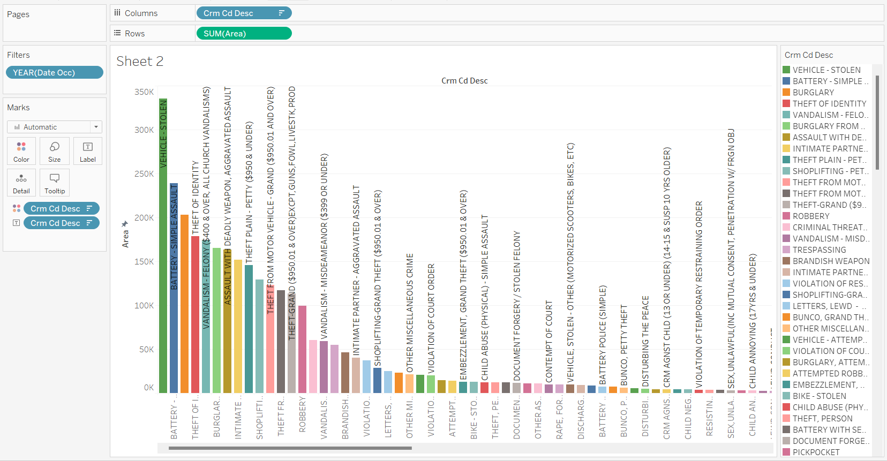

Based on the graph above, we can see that the top 5 crimes committed was Stolen Vehicle, Battery- Simple Assault, Theft of Identity, Vandalism-Felony, and Burglary. Firstly, the prevalence of Stolen Vehicle indicates a significant issue with auto theft, highlighting the need for enhanced vehicle security measures and targeted law enforcement efforts to combat this type of crime. Similarly, the occurrence of Battery-Simple Assault underscores the importance of addressing interpersonal violence and implementing strategies for conflict resolution and violence prevention. The presence of Theft of Identity points to the need for measures to protect personal information and strengthen cybersecurity. Additionally, the frequency of Vandalism-Felony suggests challenges with property crime in the hundreds if not thousands of dollars, emphasizing the importance of community engagement and initiatives to promote respect for public and private property. Lastly, the occurrence of Burglary highlights the need for improved home security measures and neighborhood watch programs to deter break-ins and protect residential areas. Overall, understanding the prevalence of these top five crimes provides valuable insights for allocating resources, implementing targeted interventions, and collaborating with the community to address safety concerns and enhance overall public safety and well-being.

1. The second implication is the areas where the top crimes are being committed. This knowledge is crucial for law enforcement agencies to allocate resources effectively, deploying patrols and implementing targeted interventions in these areas to address the root causes of crime and enhance public safety. Additionally, it underscores the importance of community engagement and collaboration in crime prevention efforts. Residents and local organizations should work together with law enforcement to identify and address the underlying factors contributing to crime in these areas, such as poverty, unemployment, and lack of access to resources.

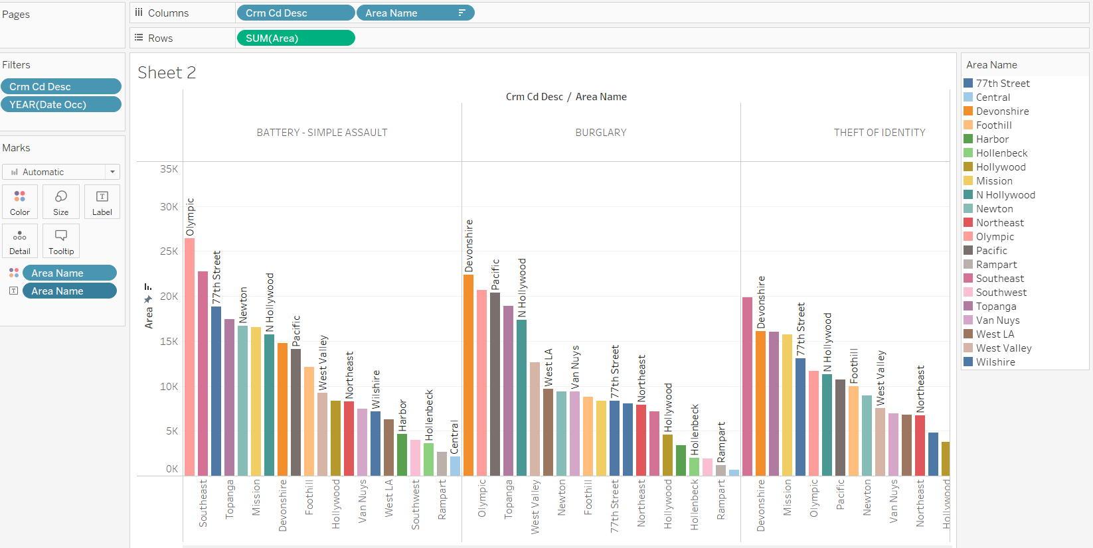

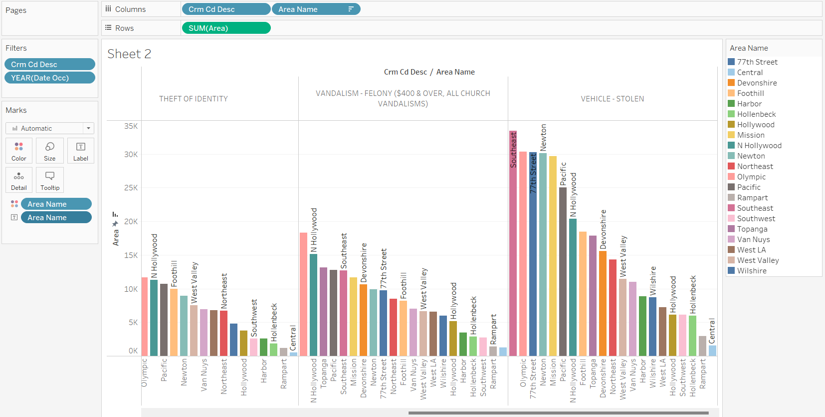

As seen in the graph above, The Southeast also had either the highest or second highest crime rate for all of the crimes mentioned above except for burglary, where it wasn’t even in the top ten. Olympic provided the most consistent crime rate, also being either first or second highest in all except for Theft of Identity. Unlike Southeast, however, Olympic was the 6th highest in this category, making it not have a significant drop off like Southeast. Topanga placed in the top five four times, at 3rd and 4th each time and 9th place outside of the top 5. 77th Street placed 3 times and Devonshire placed twice. Devonshire’s top five placements were at 1st in Burglary and 2nd in Theft of Identity though, so it remains dangerous in those two avenues.

Save or Export your project as a Tableau packaged workbook file and provide it as part of the github repository.